**Date : 20-07-2018**

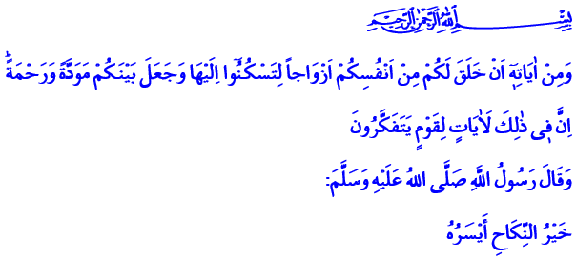

**WEDDING ETIQUETTE**

**Jumu’ah Mubarak Honorable Believers!**

Our Prophet (s.a.w.) married his dear daughter Fatimah and his uncle’s son Ali in the second year of his the Hijrah to Madinah. Fatimah’s dowry consisted of just a piece velvet, a lyster bag and a pillow filled with a redolent herb called idhkhir. Fatimah’s wedding dinner was just as plain and humble as her bridewealth (mahr) and dowry. Despite that, those who witnessed the Prophet’s (s.a.w.) daughter’s wedding said, **“We have not seen a more beautiful wedding than this.”[1]**

**Honorable Believers!**

Marriage is the order of Allah (s.w.t.) and the Sunnah of our Prophet (s.a.w.). It is a precious beginning that leads someone to peace, happiness, blessing and heaven in both this world and afterlife. As expressed by our Prophet (s.a.w.) words marriage is the means **“to protect the half of religion.”[2]**

Our first step to marriage, our weddings are the ceremonies that take place with our loved ones’ best wishes and their presence. Establishment of a new family is announced with a wedding; two lives get united at one home. Hopes regarding the future get stronger, joys of life are shared. Everybody prays to Allah (s.w.t.) for healthy, benevolent generations, habituation, affection and mercy.

**My Dear Brother and Sisters!**

Our beloved Prophet (s.a.w.), who was an example to his ummah with his life, prayed for newlyweds, saying **“May Allah (s.w.t.) make this wedding blessed for you.”[3]** He allowed for decent entertainment in joyful and happy wedding occasions. As such; unpretentious, modest, warm and moderate wedding ceremonies are of his Sunnah because one of the most important measures of life for believers is to avoid extravagancy. Being balanced is always essential in servitude to Allah (s.w.t.), in happiness, anger, sorrow, and entertainment.

**Dear Muslims!**

The Holy Qur’an asks believers to support each other in the matter of marriage and starting a family, our Prophet (s.a.w.) heralded that Allah (s.w.t) will help those who intend to marry. What is essential in Islam is to facilitate marriage. Therefore, forgetting our Prophet’s (s.a.w) principle that says **“The most fruitful wedding is the one with least burden.”[4]** usually causes material and moral damages. Redundant wedding spending at every stage to marriage put families into trouble. Young people who want to marry get into trouble because wedding expenses are over reasonable limits, even avoid marriage just because of that. Paying debts for a long time after wedding causes a family’s early years to pass in financial distress and unrest. However, in simplicity there is nobility, and in humbleness there is wisdom.

**Venerable Muslims!**

Our Prophet (s.a.w.) advised one of his newlywed companions to **“Give a wedding dinner even with only a sheep.”[5]** However, our wedding dinners, which are supposed to be where our friends meet and share happiness, should not turn into the tables of squander, vanity and gaudiness. Our Prophet (s.a.w.) demanded not to make any difference between rich and poor while making wedding invitations. He described wedding dinners which invited the rich but forgot the poor as “the worst meal.” [6]

**Dear Muslims!**

What is appropriate for believers is to act according to what Islam deemed rightful in our marriage, engagement, circumcision and wedding ceremonies. Being temperate and balanced in entertainment is to observe Islamic principles, and to obey the following expression of Allah (s.w.t.) by heart: **“O you who have believed, do not prohibit the good things which Allah (s.w.t.) has made lawful to you and do not transgress. Indeed, Allah does not like transgressors.”[7]**

A believer cannot be slack about haram actions by taking shelter in the excuse of “his or her children’s happiness.” A believer does not resort to mind-numbing things like alcohol, drugs and guns which turn happiness to sorrow, or does not violate anyone’s privacy while pursuing happiness. A believer does not violate anyone’s rights or disturb anyone in entertainment. A believer lives every moment with the awareness that Allah (s.w.t.) sees and observes him every moment. A believer praises Allah (s.w.t.) and acts in line with the approval of Allah (s.w.t.).

**Brothers and Sisters!**

Let us stay away from actions that could shadow our happiness in these months of frequent weddings, in which our children get married. Let us be careful about sinking into material passions, and plunging into pleasure and debauchery when making a wedding ceremony. Let us not be the captives of luxury and wastefulness on such occasions. Let us remember that life does not consist of joy and entertainment only. Let us turn our wedding ceremonies into opportunities to praise Allah (s.w.t.) who “created for us from ourselves mates that we may find tranquility in them; placed between us affection and mercy.”[8]

1. Ibn Majah, Marriage, 24
2. Al-Bayhaqi, Shuab al-Iman IV, 382
3. Muslim, Marriage, 79
4. Ibn Hanbal, VI, 83
5. Bukhari, Marriage, 69
6. Bukhari, Marriage, 73
7. Ma’idah, 5/87
8. Rum, 30/21

   ***Issued by: General Directorate of Religious Services***